Instructions:

This form must be completed by the event organizer and the emergency action plan described must be in place before the event is sanctioned by Cycling BC.

Copies of the completed form must be distributed to all persons responsible for event safety including the safety coordinator, marshals, first aid attendants, et al.

A copy must be available for inspection by event officials or Cycling BC representatives upon request.

Minimum Requirements:

- A single person must be identified as the in-charge first aid attendant.
- This person must always be available during the event.
- This person must be able to receive contact from course marshals (or via the head organizer who is in contact with all the course marshals) and be stationed at an identifiable First Aid post.

Training Requirements:

The in-charge First Aid Attendant must have at the minimum:
- Occupational First Aid (OFA 1) or
- Standard First Aid (SFA 1) (Explore Training Dates)

The in-charge Attendant must have a complete first aid kit on site and ice bags are recommended.

NOTE: The higher level is strongly recommended especially for those events that are greater than 10km away from an Ambulance Dispatch. Events with more than 20 participants must have at least 2 certified first attendants.

First Aid Personal:

Name: |  | Certification:
Name: |  | Certification:
Name: |  | Certification:

- Charge Person Responsibilities
  - Conduct an initial assessment of the injury.
  - Designate someone to watch the other participants (stop all activities and ensure all participants are in a safe area if nobody is available to supervise).
  - Wait with the injured participant and help keep them calm until emergency medical services arrive and conduct their assessment of the injury.
  - Record the injury using their club’s accident report form.

- Call Person Responsibilities
  - Call for emergency help.
  - Provide all necessary information to dispatch.
  - The facility location
  - The closest access door to the injured participant
  - The nature of the injury
  - A description of first aid that has been performed
  - Other medical information, such as allergies or medical conditions

- Next Steps
  - Clear any traffic from the facility entrance or access road before the ambulance arrives.
  - Wait by the entrance to direct the ambulance.
  - Call the participant’s emergency contact person**
  - Assist the charge person as needed.
  - Verbal report to EHS
  - Send helmet with patient

- Debrief
  - Inform Cycling BC iRide of accident (604-224-7433)
  - Submit accident report @ cyclingbc.net/accident
  - Inform Venue/Facility Manager of incident on their property
  - Restock 1st Aid Kit
  - Follow up with Parent or Rider the next day. Plan to transport bicycle.

**For children who are under the care of the ministry (foster-care, etc), the Ministry must be contact BEFORE the child’s guardian is to be contacted.

REMINDERS
When preparing for away competitions, ask the host team or host facility for a copy of their EAP in advance.
Attach the medical profile and parent or caregiver contact information for each participant to this emergency action plan.

Use the below template. Email to iride@cyclingbc.net

iRide After-School EAP Template

Venue / Location:
Name:
Address: | Address, City, Province
Additional Notes (directions to location)
Venue Manager: |  | (###) ### - ####

Staff On-Site:
Charge Person: |  | (###) ### - ####
Call Person: |  | (###) ### - ####
Backup: |  | (###) ### - ####

Important Contacts:
IN AN EMERGENCY… CALL … |  | 911
Non-Emergency | RCMP | (###) ### - ####
 | Fire-Rescue | (###) ### - ####
 | City | (###) ### - ####
 | Needle Pickup | (###) ### - ####

Nearest Hospital:
Hospital Name:
Address: | Address, City, Province

Coaches Checklist:
- Pre-Site Inspection + Knowledge of Area
- 1st Aid Kit
- Emergency Contact List (DOWNLOAD INSTRUCTIONS)
- Tools
  - Flat Kit: Pump, Tire levers, Spare tubes (various sizes), Patch Kit
  - Other: Allen keys, Duct tape, Zap straps, Chain Breaker
- Sustenance
  - Water & Food (extra snacks for participants)
  - Spare Clothing

Insert Trail Map: |  | (right click image to change & upload new)
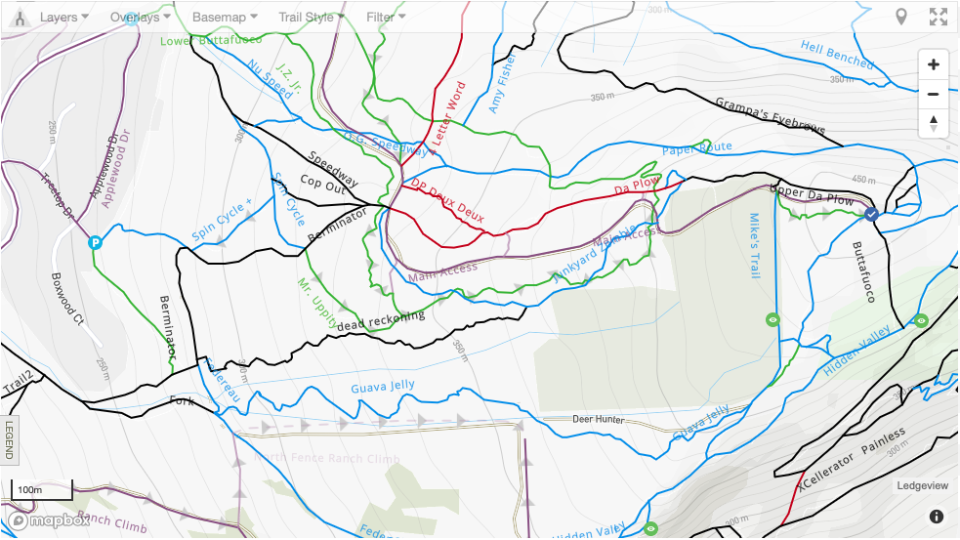
List Trail Names: | - __  - __  - __  - __  - __

Insert Map of Hospital Directions | (right click image to change & upload new)
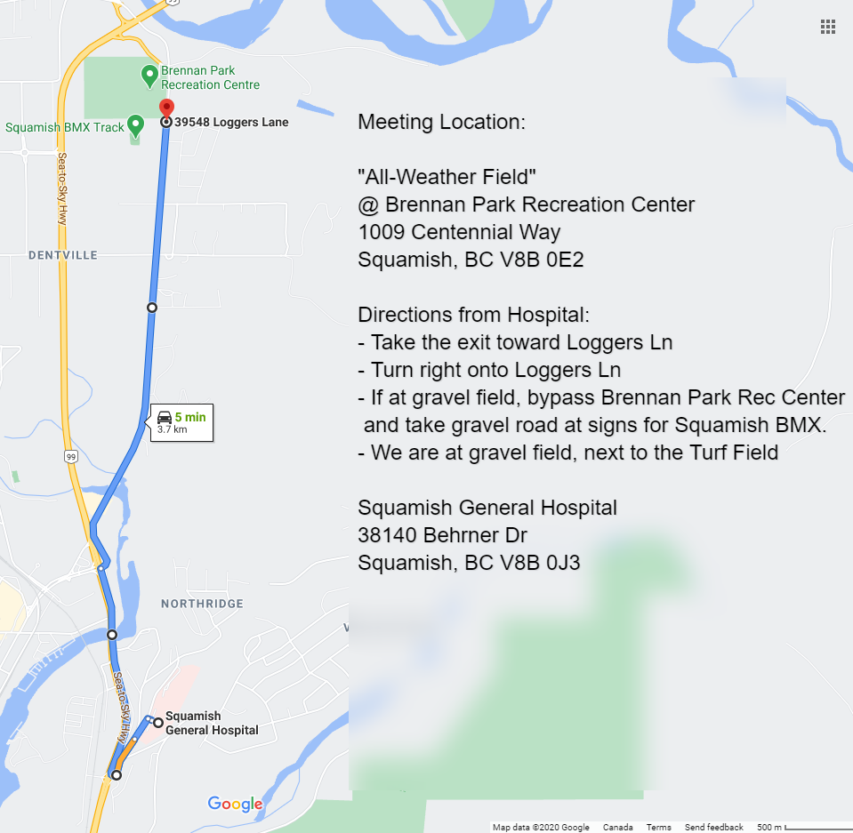

Use Google Maps & Screenshot to capture a similar image.

Participant Contacts |  |  | Print CCN Reg list or transcribe here
Rider Name | Medical Info | Photo Consent? | Emergency  Name | Emergency  Phone
*right click to insert more rows

Risk Management Checklist

I am ready to ride because I have completed the following…
- I have completed required NCCP Coach Training and/or Certification
- I have checked in my participants & assessed their skills
- I have appropriate first aid supplies
- I have a printed emergency action plan
- I have conducted a pre-event inspection of the area
- Participants have signed liability waiver or shown membership
- This club activity is registered with Cycling BC = access to insurance
- I will stop this activity if unreasonable risks develop
- I will use my common sense & intuition to uphold the duty of care
- I will continue to pursue on-going professional coach development

