Cycling Canada's Quad in Review 2008-2012 - Talent ID
- Report on Cycling Canada's talent ID and development initiatives 2008 - 2012 quad in review by Jacques Landry

2008-2012 Quadrennial Plan in Review – Competition Gap Analysis
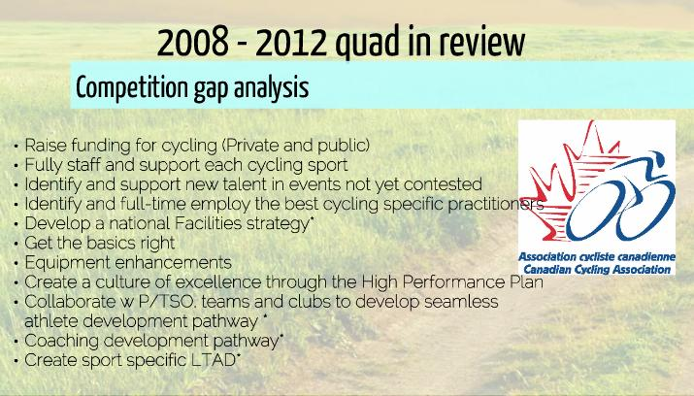

2008-2012 Quadrennial Plan in Review – Four Pillars of Performance
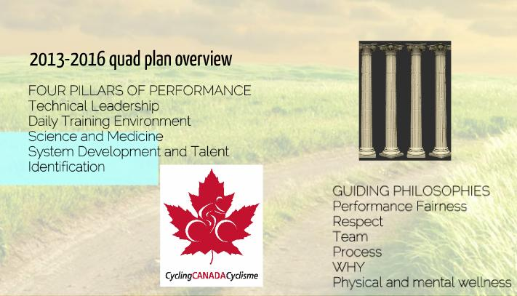

2008-2012 Quadrennial Plan in Review – Four Pillars continued
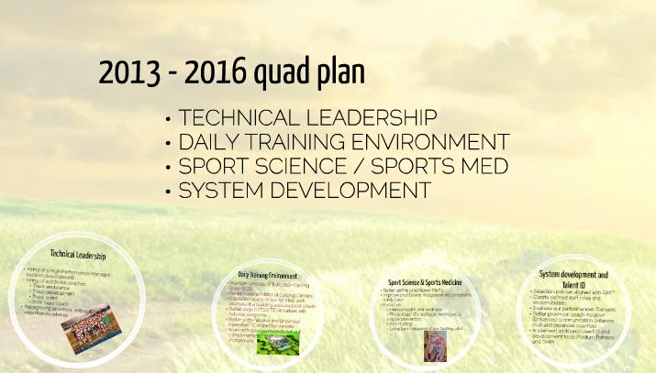

2008-2012 Quadrennial Plan in Review – PILLARS - #1 Technical Leadership & #2 Daily Training Environment
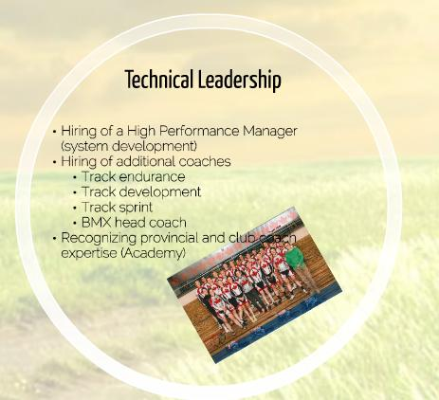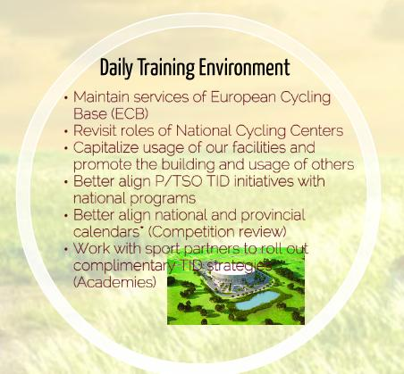

2008-2012 Quadrennial Plan in Review – PILLARS - #3 Sport Science/Medicine & #4 System Dev. & Talent ID
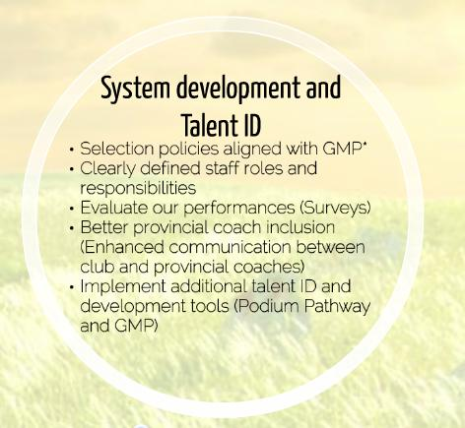

2008-2012 Quadrennial Plan in Review – Talent ID & Development Tools
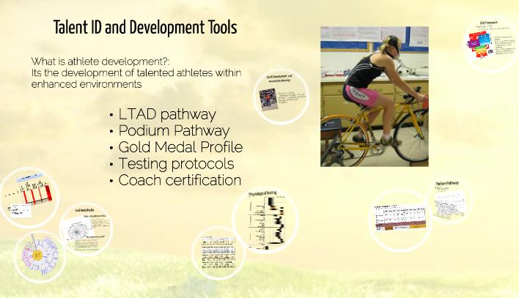

2008-2012 Quadrennial Plan in Review – LTAD Framework & Podium Pathway
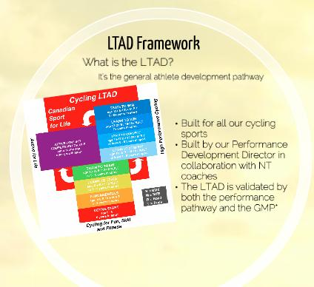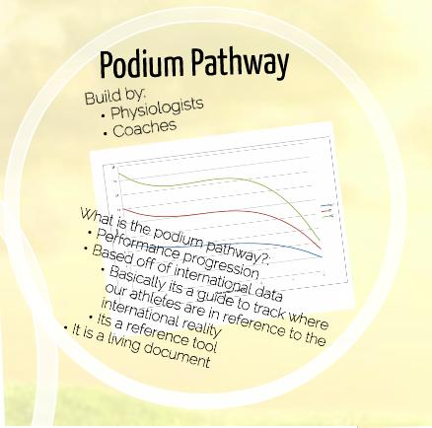

2008-2012 Quadrennial Plan in Review –Podium Pathway Example & Podium Profile
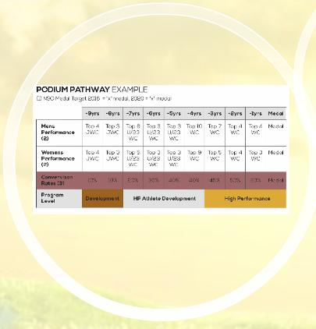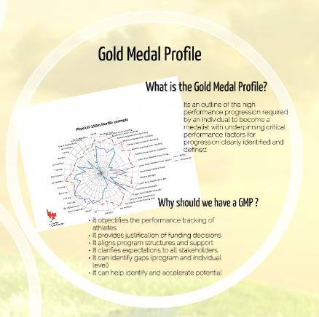

2008-2012 Quadrennial Plan in Review – Cycling Sprint & Rider Performance Matrices
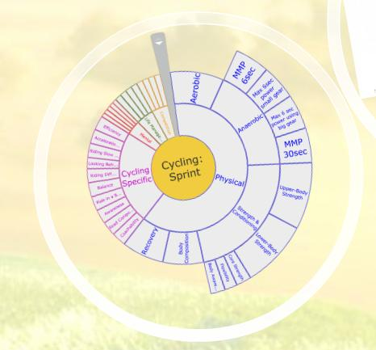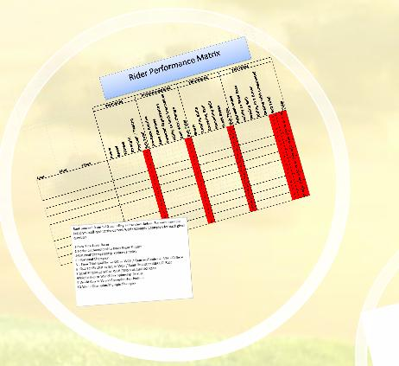

2008-2012 Quadrennial Plan in Review – Physiological Testing Results Part 1 & 2
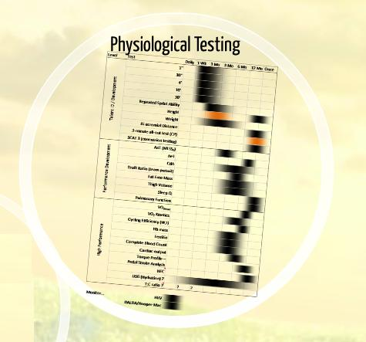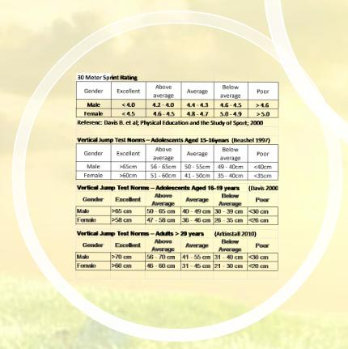

2008-2012 Quadrennial Plan in Review – Coach Development & Succession Planning
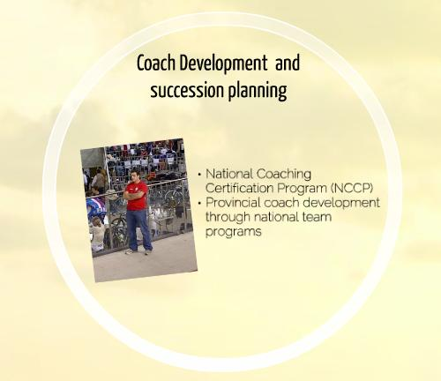

Prezi Report can be found at: Cycling Canada's Quadrennial Plan in Review Nov 5th, 2013

